SALESFORCE PROJECT IMPLEMENTATION PHASES

**Phase 1:** Problem Understanding & Industry Analysis

**Problem:** During natural disasters (floods, earthquakes, cyclones), victims often struggle to request essential resources efficiently, and NGOs/government agencies have difficulty tracking requests and assigning volunteers/resources.

**Industry Analysis:**

* Sector: Disaster Management / Humanitarian Aid
* Current Challenges:
  + Delayed response due to manual request tracking
  + Lack of real-time visibility of volunteer availability
  + Inefficient allocation of resources
* Salesforce Role: Centralized system to manage requests, volunteers, and resources with automation and dashboards.

**1. Requirement Gathering**

* Victims should be able to submit requests for essential resources (food, water, medicine, shelter).
* Volunteers should be able to view and accept/complete assignments.
* Coordinators should have a dashboard to track requests, volunteers, and resources.
* The system should automatically assign volunteers/resources based on availability and priority.
* Notifications/alerts for pending or overdue requests.
* Reports and analytics for completed vs pending requests, resource utilization, and volunteer workload.

**2. Stakeholder Analysis**

|  |  |  |
| --- | --- | --- |
| **Stakeholder** | **Role** | **Expectations** |
| Victims (Affected People) | Submit resource requests | Easy-to-use portal, real-time tracking |
| Volunteers | Fulfill requests | Clear assignments, update status easily |
| Coordinators/NGOs | Manage relief operations | Central dashboard, automated assignment, analytics |
| Government Agencies | Oversight/monitoring | Reports, transparency, faster response |

**3. Business Process Mapping**

**Process Flow:**

1. Victim submits a request.
2. System validates request and auto-assigns volunteer/resource.
3. Volunteer receives task notification and updates status.
4. Coordinator tracks progress and reallocates if needed.
5. Reports and dashboards provide insights into overall relief efforts.

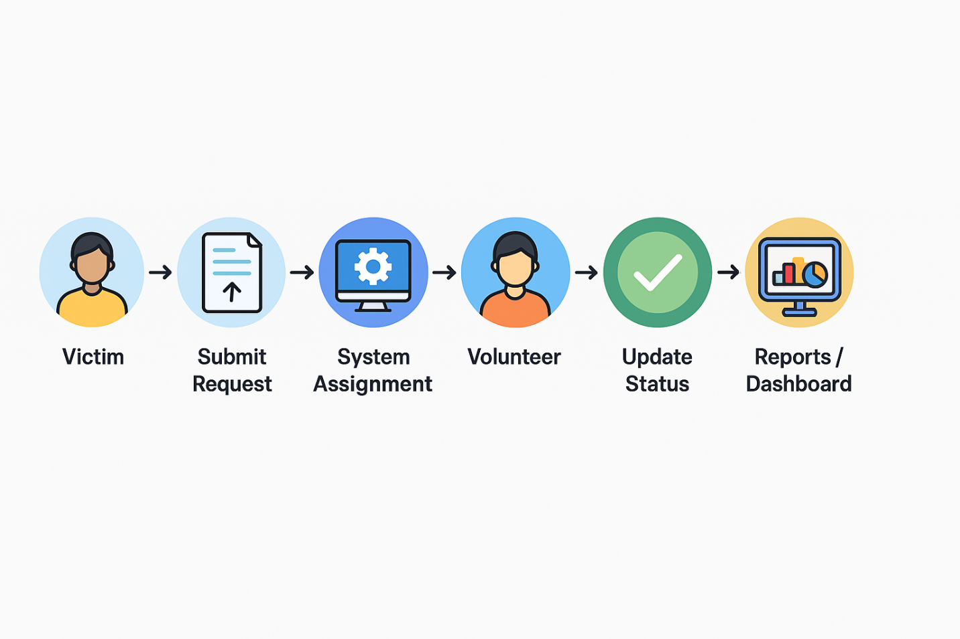

Figure 1. Process Flow Diagram

**4. Industry-specific Use Case Analysis**

* Use Case: Flood Relief in a rural district
* Victims request food, water, and shelter.
* Volunteers from NGOs and community groups are available for deployment.
* Coordinators need real-time tracking of requests and volunteer workload.
* Outcome: Faster allocation of relief resources, reduced duplication of effort, and improved victim support.

**5. AppExchange Exploration**

* Volunteer Management Apps (for NGOs) → provide partial solutions but are generic.
* Nonprofit Success Pack (NPSP) → widely used in nonprofit operations but not disaster-specific.
* Case Management Apps → good for tracking issues but lack volunteer/resource assignment logic.
* **Differentiation:** Our solution focuses specifically on disaster relief scenarios, integrates volunteer and resource assignment, and includes LWC dashboards for real-time tracking — all built in a free Salesforce Developer Org.